**NEWS NAVIGATION PROJECT REPORTS**

**INSIGHT STREAM: NEWS NAVIGATION**

**Project titles: insight stream**

**Team ID: NM2025TMID37145**

**Team leader: PAVITHRA R.P**

[**Karanpavithra2006@gmail.com**](mailto:Karanpavithra2006@gmail.com)

**Team members:**

**DIVYA DHARSHINI.S:** [**divyadharshinidharshini70@gmail.com**](mailto:divyadharshinidharshini70@gmail.com)

**SRIMATHI I:** [**srimathii390@gmail.com**](mailto:srimathii390@gmail.com)

**DURGA SRI S:** [**durgasiva5678@gmail.com**](mailto:durgasiva5678@gmail.com)

**INTRODUCTION**

**Insight Stream News Landscape**

In today's rapidly evolving media environment, staying informed is no longer just about receiving news—it's about understanding the context, source, and impact behind every headline. The **Insight Stream News Landscape** explores this modern reality by examining how news is created, distributed, and consumed in a digital-first world. With the rise of real-time information flows, social media platforms, and algorithm-driven content curation, the landscape of news has become both more accessible and more complex.

This topic focuses on the intersection of journalism, technology, and public perception. It looks at how traditional media outlets are adapting to digital disruption, how independent voices are gaining ground, and how misinformation challenges the credibility of legitimate news sources. The Insight Stream doesn't simply track the latest events; it analyzes the patterns, trends, and underlying narratives that shape how societies understand current affairs.

Moreover, this landscape is influenced heavily by changing audience behaviors. People now interact with news differently—scrolling through headlines, engaging with short-form content, and often encountering information through platforms not originally designed for journalism. These shifts raise important questions about media literacy, trust, and the role of journalism in democratic societies.

By navigating this complex terrain, the Insight Stream News Landscape offers a clearer, more informed view of the global information ecosystem. It provides critical insight into how stories gain traction, why certain issues dominate public discourse, and what that means for the future of communication. In doing so, it equips readers with the tools to think critically, engage responsibly, and stay meaningfully informed in an age defined by constant connectivity.

**Source code**

import 'bootstrap/dist/css/bootstrap.min.css';

@import url('https://fonts.googleapis.com/css2?family=Poppins:wght@200;300;400;500;600;700;800;900&family=Whisper&display=swap');

body {

  margin: 0;

  font-family: 'Poppins', sans-serif;

  -webkit-font-smoothing: antialiased;

  -moz-osx-font-smoothing: grayscale;

  -ms-overflow-style: none;  /* IE and Edge */

  scrollbar-width: none;

}

body::-webkit-scrollbar {

  display: none;

}

code {

  font-family: source-code-pro, Menlo, Monaco, Consolas, 'Courier New',

    monospace;

}

.spinners{

  display: flex;

  justify-content: center;

  align-items: center;

  gap: 10px;

}

import { render, screen } from '@testing-library/react';

import App from './App';

test('renders learn react link', () => {

  render(<App />);

  const linkElement = screen.getByText(/learn react/i);

  expect(linkElement).toBeInTheDocument();

});

@import 'bootstrap/dist/css/bootstrap.min.css';

@import url('https://fonts.googleapis.com/css2?family=Poppins:wght@200;300;400;500;600;700;800;900&family=Whisper&display=swap');

body {

  margin: 0;

  font-family: 'Poppins', sans-serif;

  -webkit-font-smoothing: antialiased;

  -moz-osx-font-smoothing: grayscale;

  -ms-overflow-style: none;  /* IE and Edge */

  scrollbar-width: none;

}

body::-webkit-scrollbar {

  display: none;

}

code {

  font-family: source-code-pro, Menlo, Monaco, Consolas, 'Courier New',

    monospace;

}

.spinners{

  display: flex;

  justify-content: center;

  align-items: center;

  gap: 10px;

}

import React from 'react';

import ReactDOM from 'react-dom/client';

import './index.css';

import App from './App';

import reportWebVitals from './reportWebVitals';

import { BrowserRouter } from 'react-router-dom';

import GeneralContextProvider from './context/GeneralContext';

const root = ReactDOM.createRoot(document.getElementById('root'));

root.render(

  <BrowserRouter>

        <GeneralContextProvider>

              <App />

        </GeneralContextProvider>

    </BrowserRouter>

);

// If you want to start measuring performance in your app, pass a function

// to log results (for example: reportWebVitals(console.log))

// or send to an analytics endpoint. Learn more: https://bit.ly/CRA-vitals

reportWebVitals();

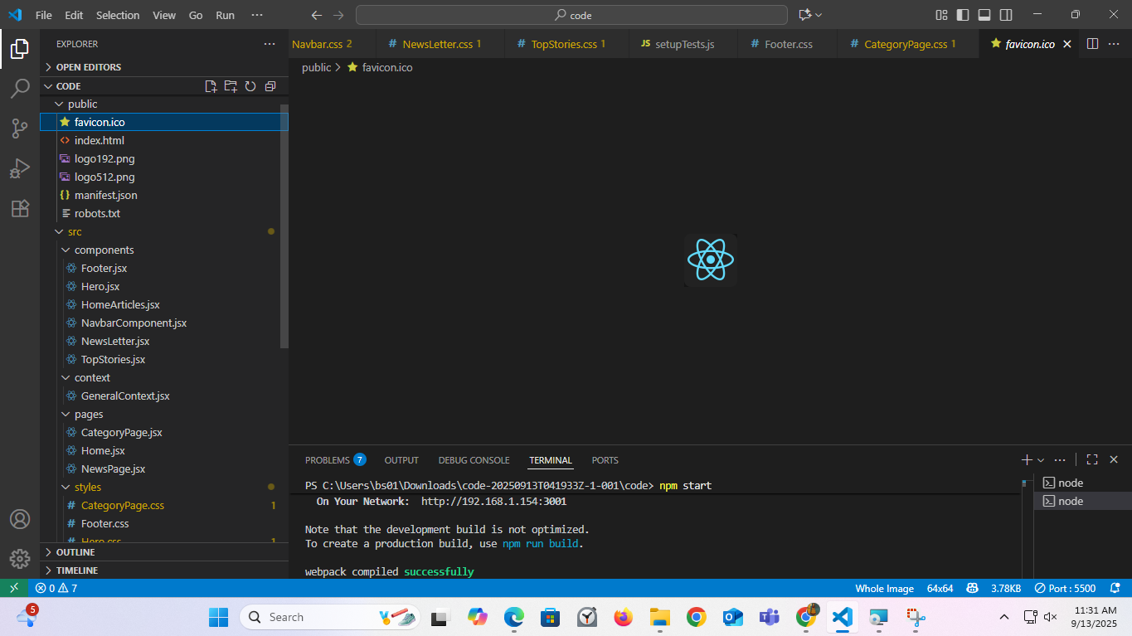

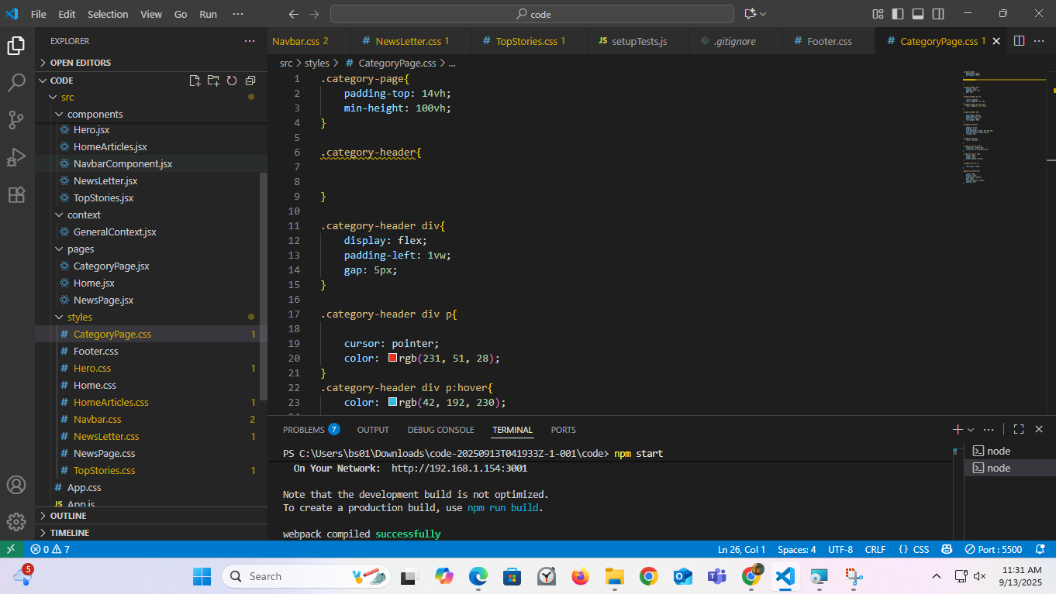

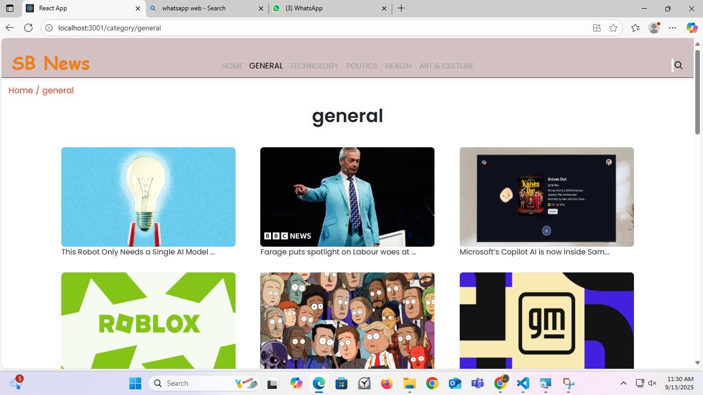

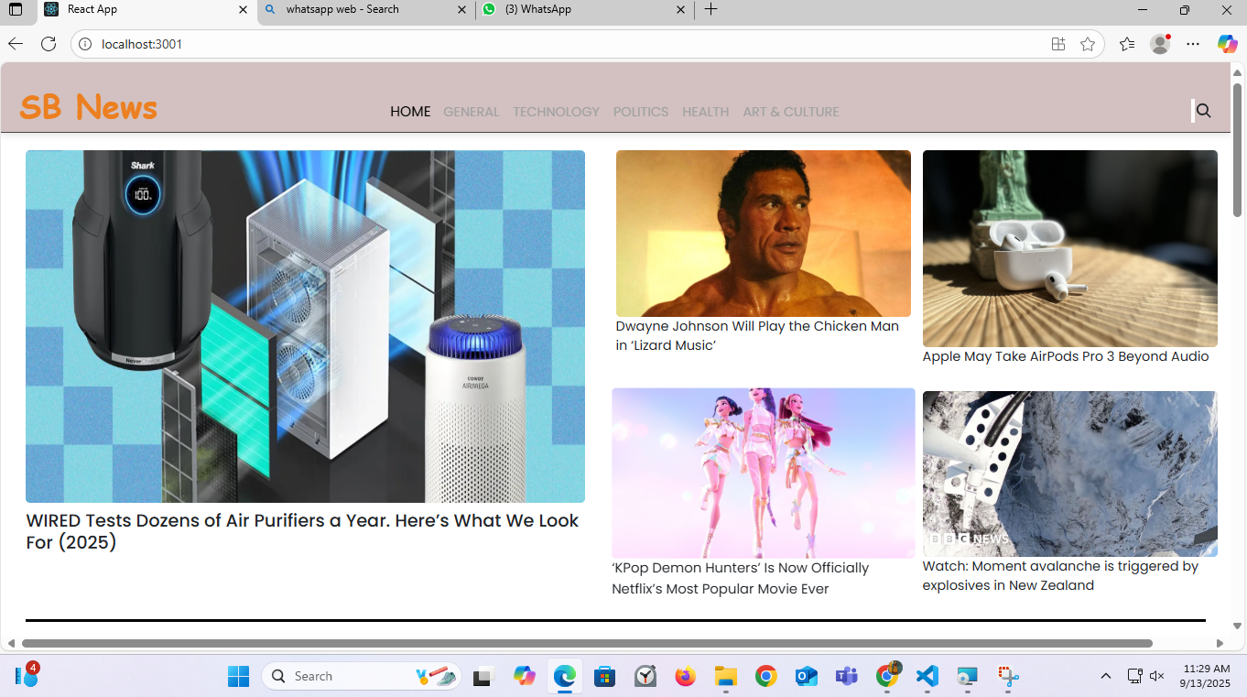

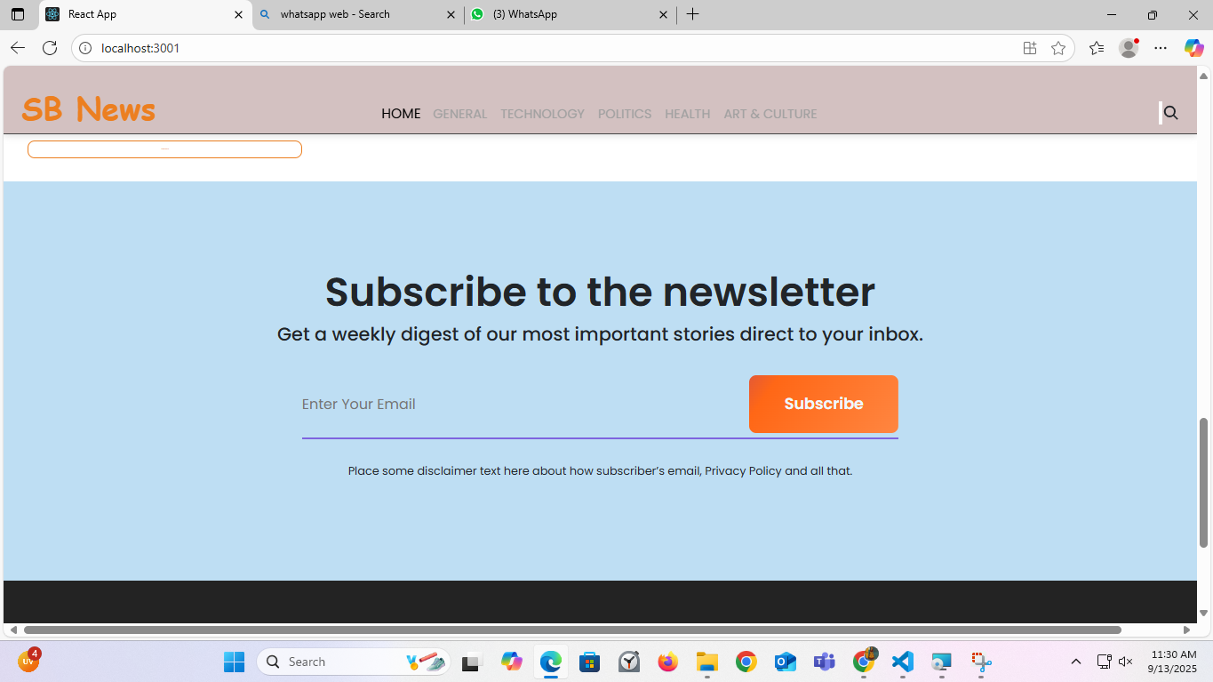

DEMO LINK

The demo can be hosted locally by opening the HTML file in a browser. Alternatively , it can be deployed using platform like GitHub pages ,

Netlify or vercel . Example demo link https://drive.google.com/file/d/1hF3ByyWAstqVfooInP5kXd0kl7ZI4lQp/view?usp=sharing